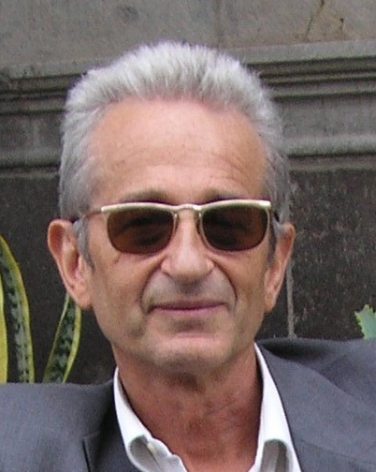

Sandro Dernini, Ph.D.
Coordinator
Forum on Mediterranean Food Cultures
Rome
E-mail: s.dernini@tiscali.it

Born in Cagliari, Sardinia, Italy, in 1949.
Doctorate in Biology, School of Science, University of Cagliari, Italy (1974);
PhD. in Art Education, School of Education, New York University (1997).

FAO consultant (2010-2012) for the development of sustainable diets assessments;
FAO consultant (2012-present) for the development of FAO-UNEP sustainable food systems programme;
Coordinator of the Forum on Mediterranean Food Cultures (2002-present);
Coordinator of the CIISCAM-International Interuniversity Studies Centre on Mediterranean Food Cultures at the Sapienza University of Rome (2006-present);
Professor at the School of Specialization in Food Science at the Sapienza University of Rome (2008-2011);
Coordinator of Plexus International (1982-present);
Scientific Head of the President's Technical Secretariat of the Italian National Research Institute on Food and Nutrition (2007-2010);
FAO consultant (2000-2002) for the development of FAO Network of Centres of Excellence on Food Quality, Safety and Nutrition;
Member of the International Scientific Committee of the Foundation for the Advancement of the Mediterranean Diet (2004-present);
Member of the Italian Society of Human Nutrition (2003-present);
Member of the International Scientific Committee of Nutricion sin Fronteras (2005-present).

